Power Platform Pipeline with Azure DevOps

Suparna Banerjee

# Introduction

This document covers the steps to export a solution to Azure DevOps while performing the deployment through Power Platform Pipeline.

# Steps:

1. Create a Power Platform pipeline following the steps here - <https://learn.microsoft.com/en-us/power-platform/alm/set-up-pipelines>
2. For calling a Power Automate Flow before the deployment starts for any stage, check Pre-deployment Step required . More details here - <https://learn.microsoft.com/en-us/power-platform/alm/extend-pipelines>

1. Create an Export Solution Pipeline under an Azure DevOps Project

1. Create a Pipeline variable named Solution Name with Settable at Queue time option checked. This will allow the Power Automate Flow to dynamically select the solution to export and unpack it within a folder with the same name inside the repository.

1. Pipeline Tasks

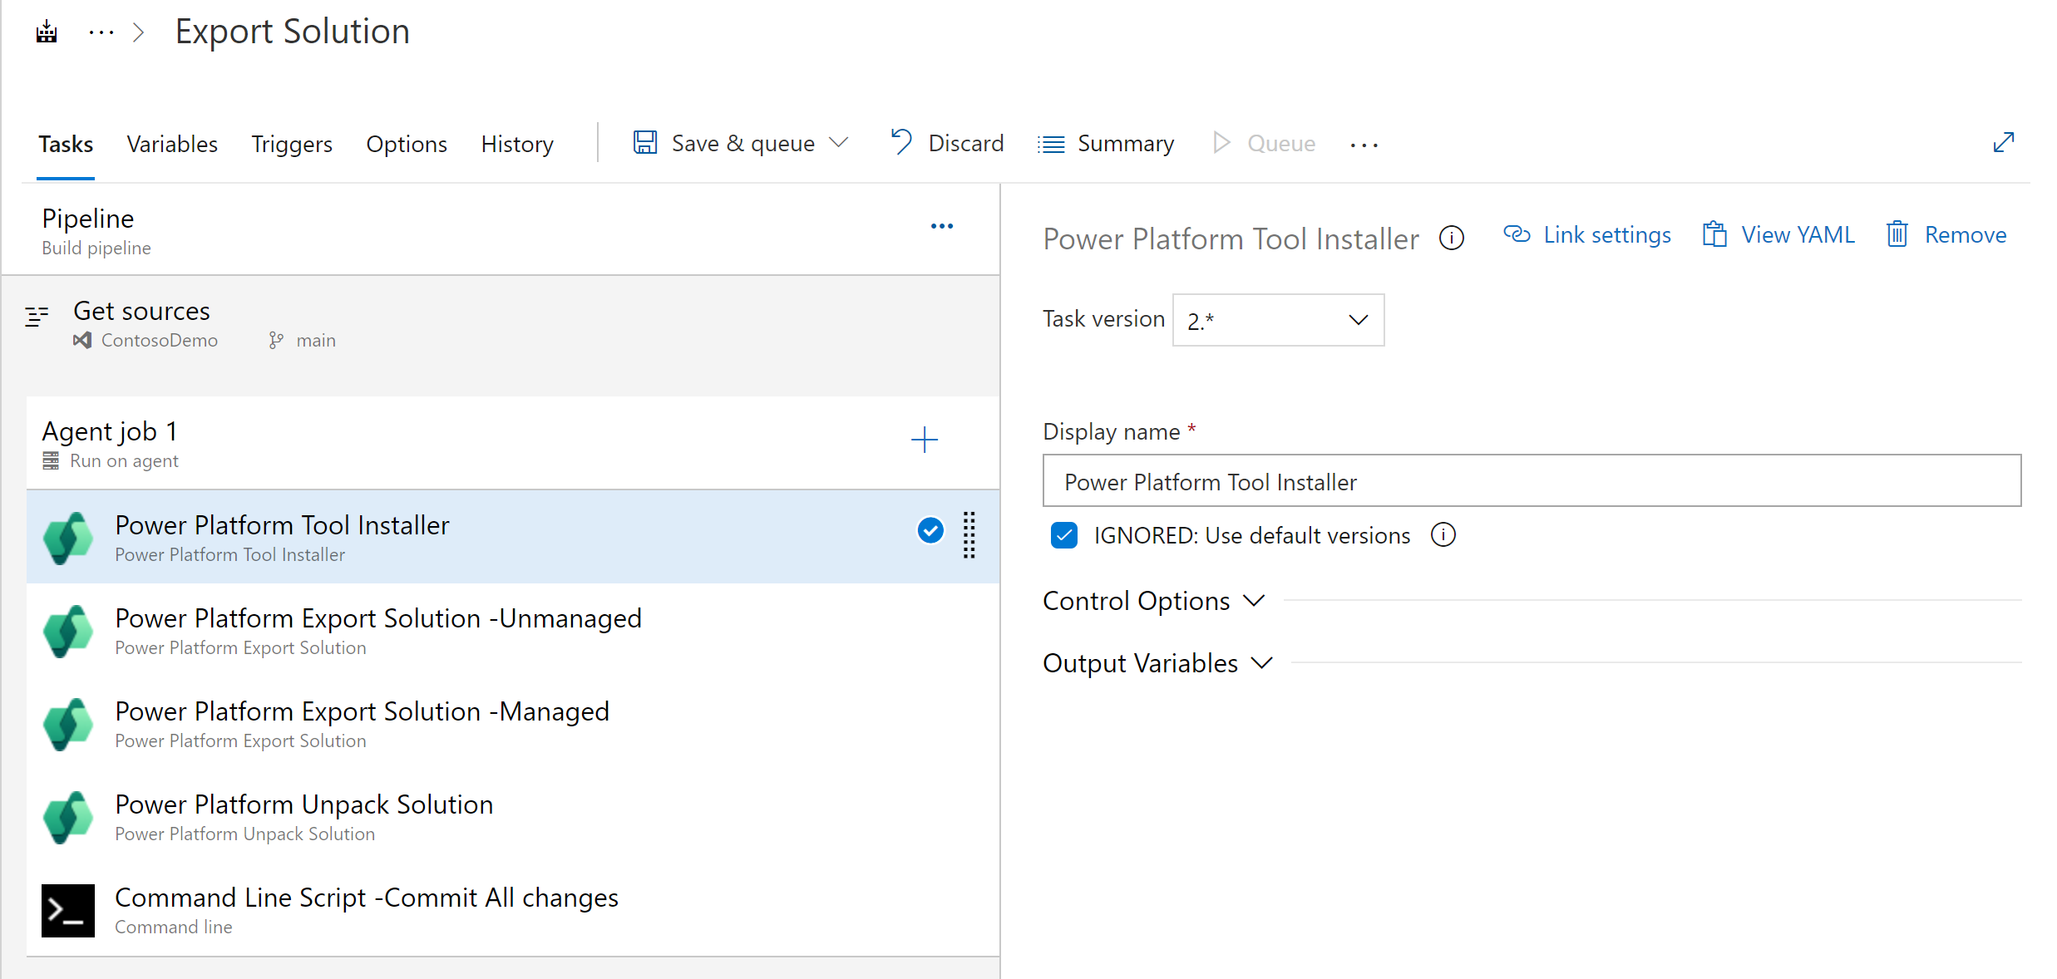

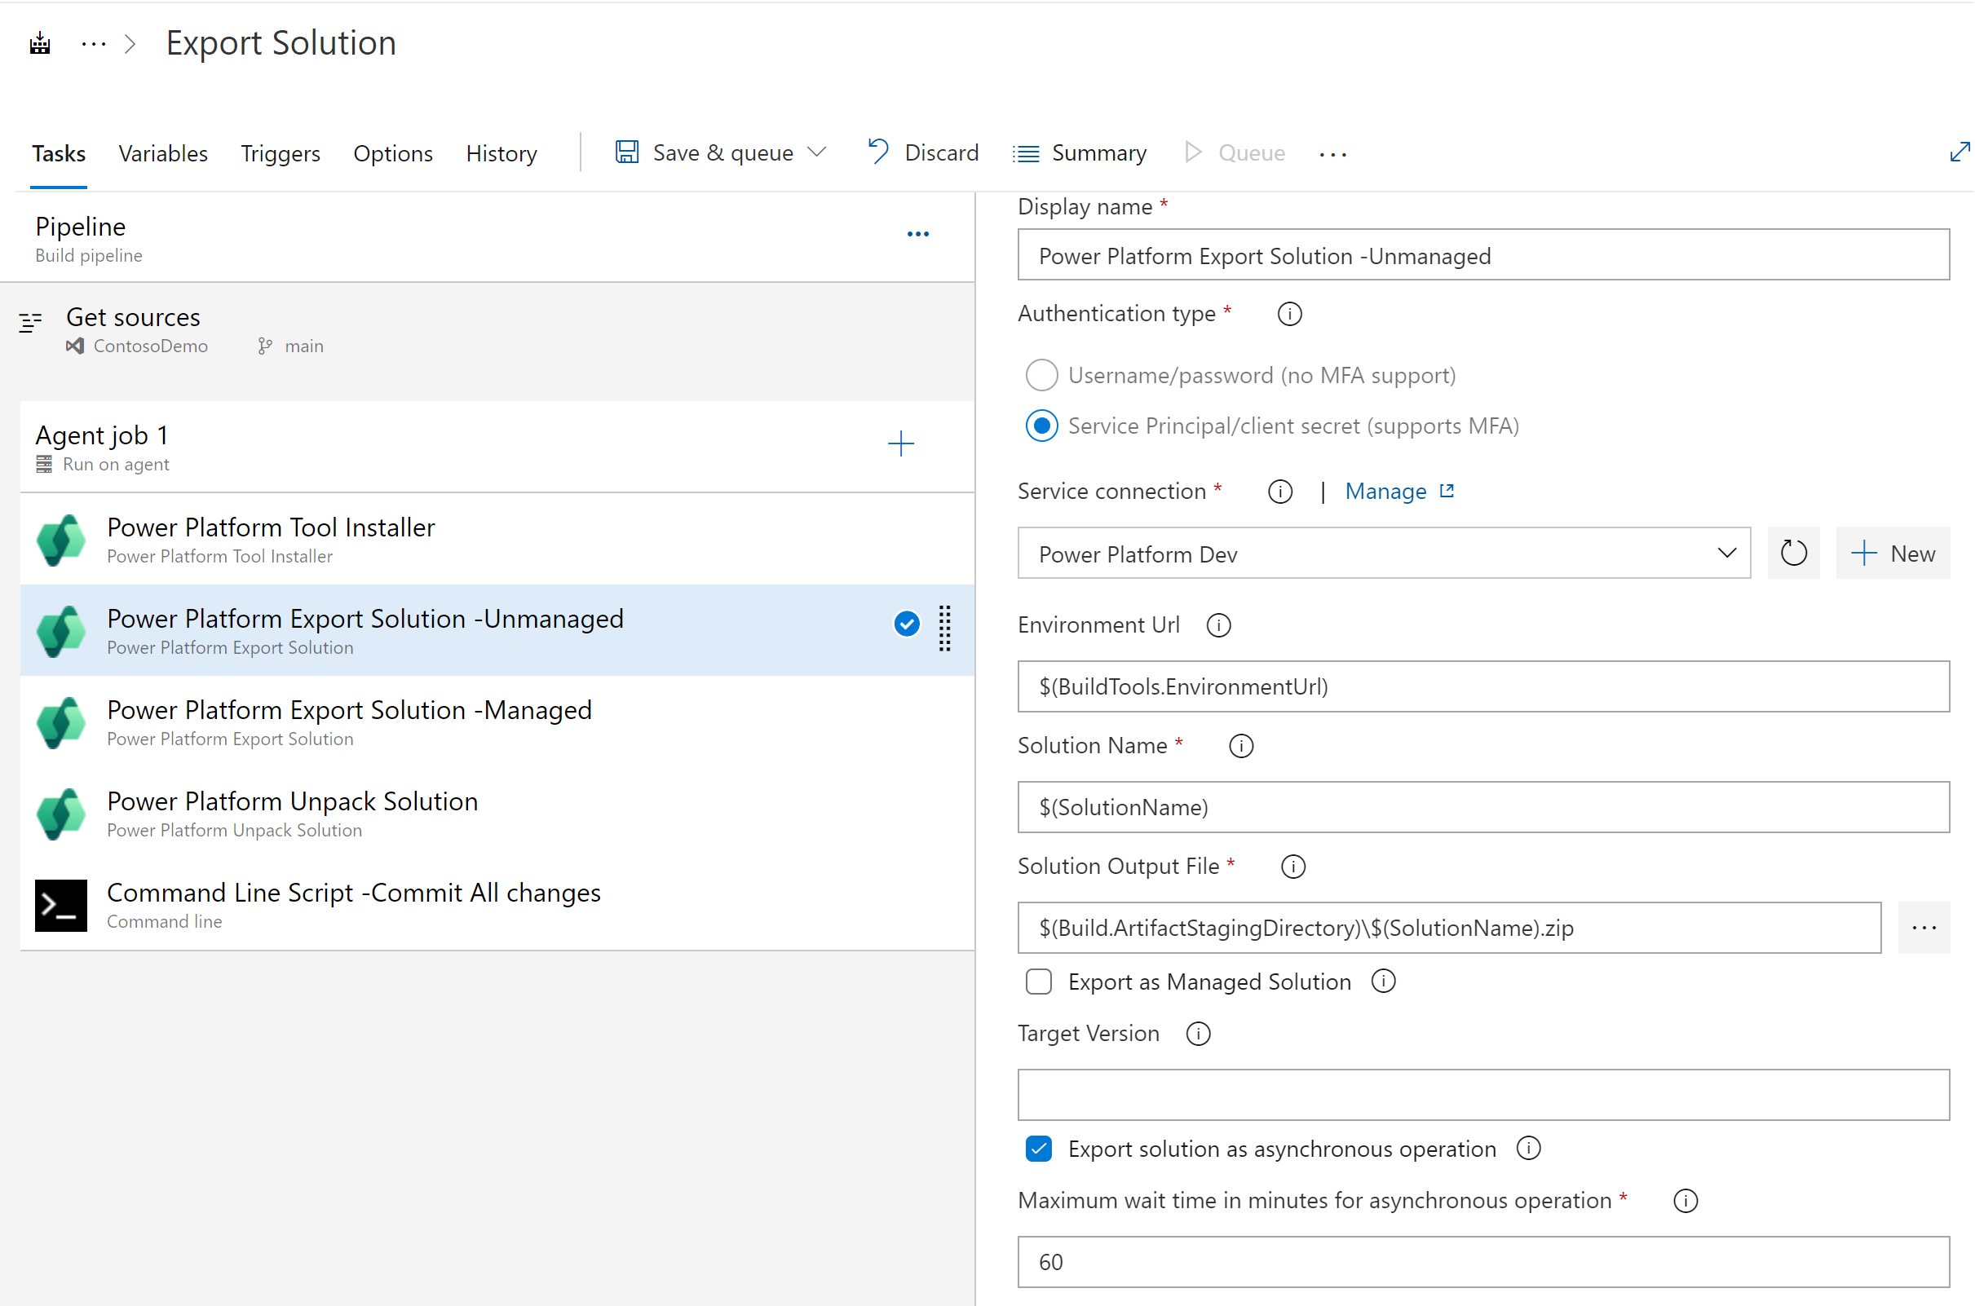

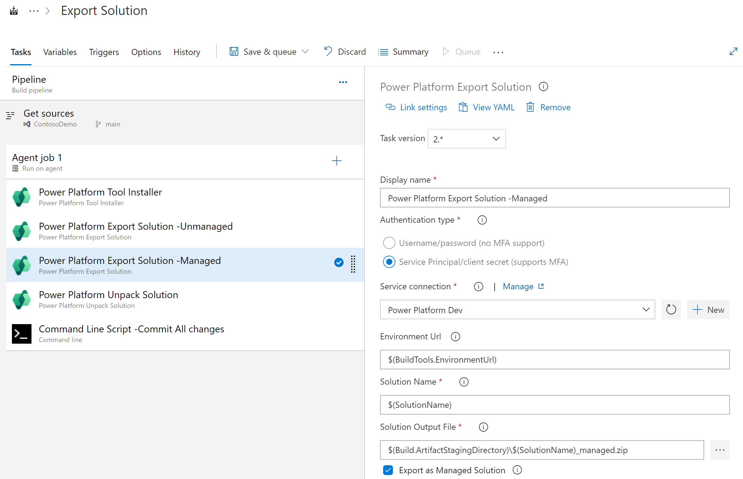

1. Import the solution Power Pipeline with Azure DevOps. It has a Cloud Flow inside it named Power Pipelines -Export solution to Azuere DevOps on OnDeploymentRequested
2. The below action calls the Azure DevOps pipeline .

REST API format for running pipeline -

POST https://dev.azure.com/{organization}/{project}/_apis/pipelines/{pipelineId}/runs?api-version=7.0

Here we are assuming that for every solution there is a project with same name , and inside that there is a pipeline named Export solution. It will create a folder with the solution name inside the repository and keep the unpacked solution.

More details here - https://suparnatechbasket.wordpress.com/2023/08/08/integrate-azure-devops-with-power-platform-pipelines/